**ESG Investing: Is it real or is it a myth?**

The **question** for this task was: „*Do you agree or disagree with the points made in the thread?*“ And then the **subtitle**: „*Your grade doesn't depend on which side you take, but depends on your argument“*

First of all, I would like to mention that for me, it not simple as that. It’s definitely not “black or white”. Comparison to politics might be the best, as one cannot say, whether someone else is either fully on the left, or fully on the right.

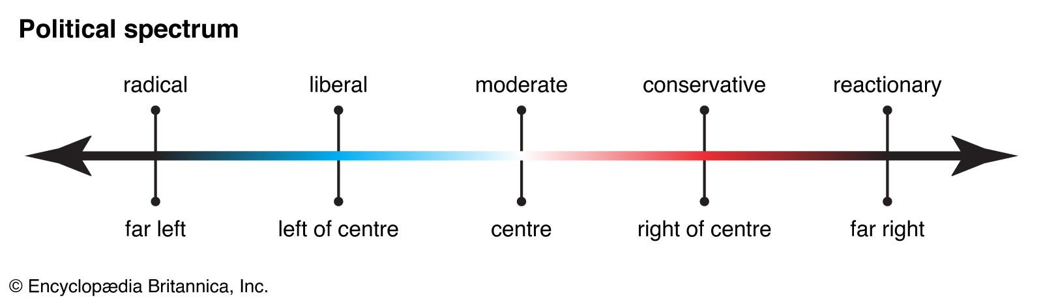https://www.britannica.com/topic/political-spectrum

Moreover, the thread & article did not mention any specific region. ESG can be a good idea in theory, but if we close half of Europe’s car industry, because they’re companies that cannot financially transform to be fully electric, or, another scenario, they get replaced by Chinese EV companies and a lot of people in Europe lose jobs, it will cause them to use cheaper material for heating for example, leading to even more CO2 production.